Experiment Number: 1
Simulation and Comparative Analysis of FDMA, TDMA and CDMA: Resource Allocation, User Capacity and Mobile-Generation Context

Objective 1,2 and 3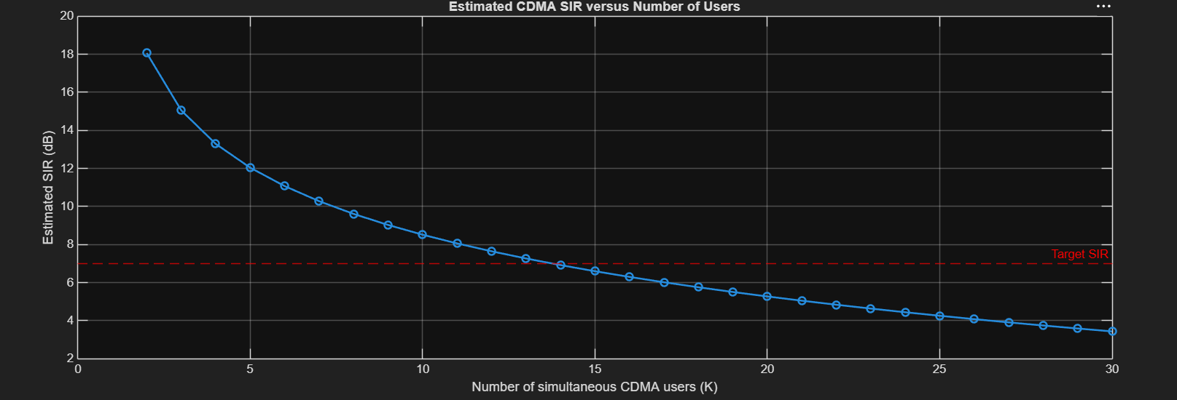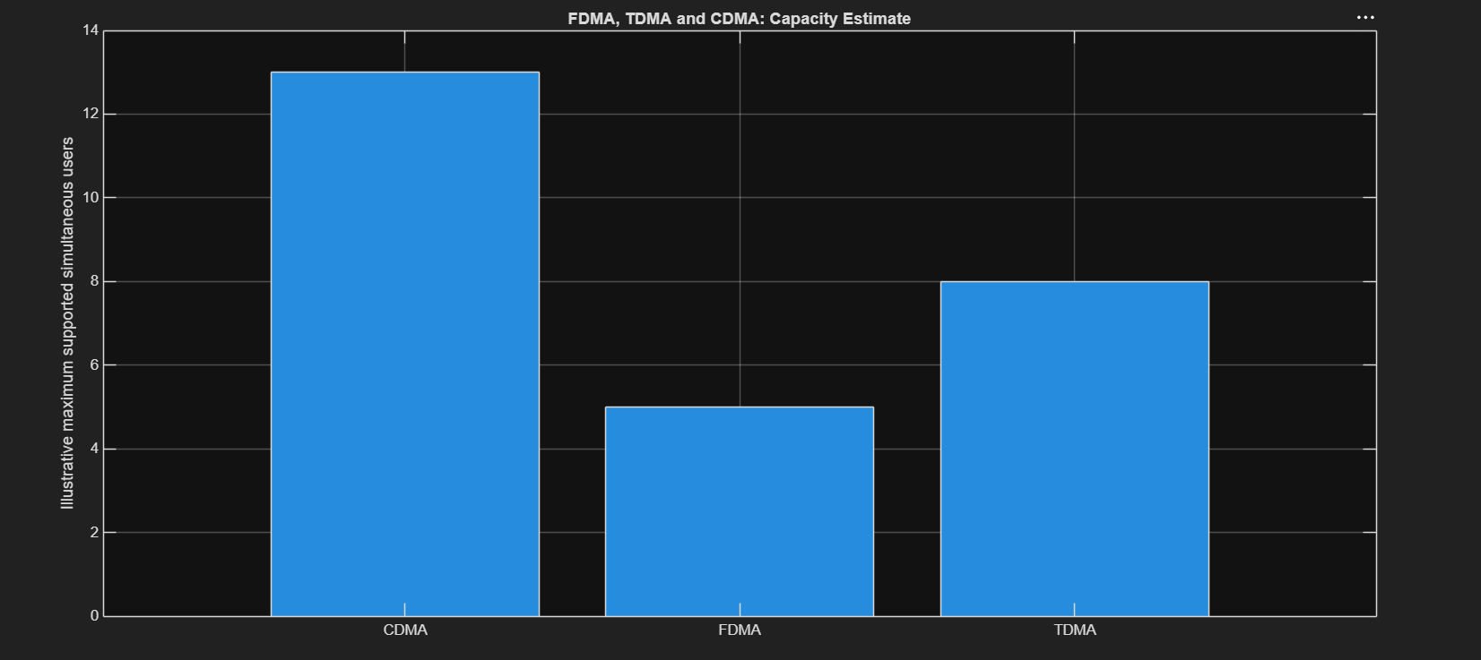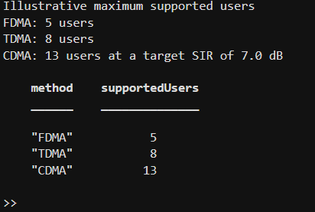
Objective 4:
